NAME: P.Pawan Teja
REG NO:- 192372303

GITHUB
EXPERIMENT - 14
AIM:
Demonstrate how to work collaboratively in Git/GitHub on a project using the fork-and-pull request workflow.

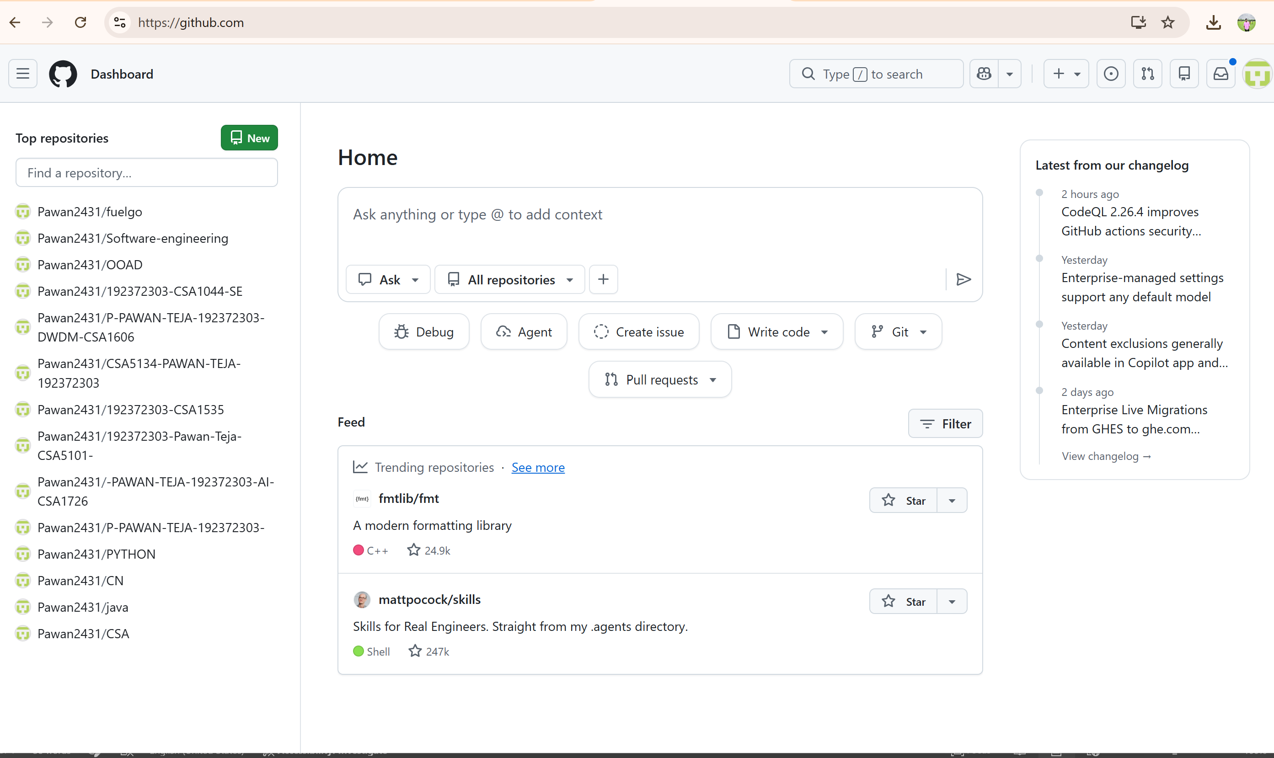

EXPERIMENT – 20
AIM: Create a GitHub Repository and Implement Version Control
